**Annex-E**

# Tech2Connect



Final Year Project Report by

### Asfand Afridi

### Sharjeel Ahmed

### Kashan Hashim

In Partial Fulfillment

Of the Requirements for the degree Bachelor of Science (CS/SE)

Sukkur IBA University, Sukkur, Sindh Pakistan (2024)

## Tech2Connect

by

## Asfand Afridi

## Sharjeel Ahmed

## Kashan Hashim

SUBMITTED TO THE DEPARTMENT OF COMPUTER SCIENCE IN PARTIAL FULFILLMENT OF THE REQUIREMENTS FOR THE DEGREE OF

##### BACHELOR OF SCIENCE IN COMPUTER SCIENCE / SOFTWARE ENGINEERING

at the SUKKUR IBA University

##### May, 2024

**© Asfand ,Sharjeel and Kashan** All rights reserved.

The author hereby grants permission to Sukkur IBA to reproduce and distribute publicly paper and electronic copies of this thesis and grant others the right to do so.

Signature of Author(s)

Signature of Author(s)

Certified by: Internal Examiner

##### Dr. Javed Ahmed Shahni and Sir Saif Hassan

##### Lecturer, CS Department (Sukkur IBA)

External Examiner

Accepted by:

**Dr.Ghulam Mujtaba Head of Department, Computer Science SIBAU**

## DECLARATION

We hereby declare that this project report entitled **Tech2Connect Project**

Submitted to the **Software Engineering Department Sukkur IBA University** is a record of an

Original work done by us under the guidance of Supervisor **Dr. Faheem Akhtar Rajput** and that no part has been plagiarized without citations. Also, this project work is submitted in the partial fulfillment of the requirements for the degree of Bachelor of Software Engineering.

|  |  |
| --- | --- |
| **Team Members** | **Signature** |
| **Asfand Afridi** |  |
| **Kashan Hashim** |  |
| **Sharjeel Ahmed** | **______________** |
|  |  |
| **Supervisor:** | **Signature** |
| **Dr. Faheem Akhtar Rajput.** |  |
| **Date:**  **03 – April - 2024** |  |
| **Place:**  Sukkur IBA University | |

## DEDICATION

We dedicate this to our parents who taught us to think clearly & motivated us to try our hardest in everything we do, without them we could not have reached our goals. This thesis is also dedicated to all those, who believe in the power of learning and willpower.

## ACKNOWLEDGEMENTS

Our heartfelt thanks go to ALLAH for having given all the necessary knowledge to plan and execute this project and the curriculum. There was never a scarcity or a need. During all this development, He took control of all that might have hindered us and helped us even in our hardest moments.

We respect Late Professor Nisar Ahmed Siddiqui; former Vice Chancellor Sukkur IBA University, for he has pursued God 's guidance and creation and nurtured the vision of Sukkur IBA University, a great institution where we were educated to take up our destiny as a royalist and dominator. We can't ignore Software Engineering Department Head and other faculty, the real gentlemen and young leaders' mentors and those persons who listen and act according to betterment for students. Nevertheless, all our teachers who have been there to motivate and guide us to achieve our goals.

Table of Content

1. Introduction …………..10

1.1. Purpose of Document 10

1.2. Intended Audience 10

1.3. Project Scope 10

1.4. Not in Scope 10

2. Overall System Description 10

2.1. Project Background 10

2.2. Product Perspective: Redefining the Gig Economy 11

2.2.1. The Gig Economy Unveiled 11

2.2.2. Community-Powered Task Assistance 11

2.3. Project Objectives: Charting a Course for Success 12

2.3.1. Efficiency and Convenience 12

2.3.2. Cost-Effective Solutions 12

2.3.3. Empower Local Communities 12

2.3.4. Create Economic Opportunities 12

2.3.5. User-Friendly Experience 12

2.3.6. Safety and Trust 12

2.3.7. Community Building 13

2.3.8. Scalability 13

2.4. Stakeholders: 13

2.4.1. Users: 13

2.4.2. Developers: 13

2.4.3. Business and management: 14

2.4.4. Legal and compliance: 14

2.4.5. Financial: 14

2.4.6. Technology and infrastructure: 14

2.4.7. Community: 14

2.4.8. Qualilty Assurance: 14

2.4.9. Government and regulatory bodies: 14

2.4.10. Educational Institutional: 14

2.4.11 Partners and third party service providers: 14

2.5. User Classes and Characteristics: The Two Pillars of Tech2Connect 15

2.5.1. Task Requesters: The Seekers of Assistance 15

2.5.2. Task Performers: The Community Helpers 15

2.6. Operating Environment: Where Tech2Connect Thrives 15

2.7. Design and Implementation Constraints: Balancing Act 16

2.8. Assumptions and Dependencies: Building Blocks of Reliability 16

2.8.1. Assumptions: 16

2.8.2. Dependencies: 17

3.0 Literature review………………………………………………………………………….17

4.0 Critical Analysis…………………………………………………………………………..20

5.0 Development Enviroment…………………………………………………………………21

5.1. Programing Languages and Framework……………………………………………...22

5.2. Development Tools…………………………………………………………………...22

5.3. Infrastructure and Hosting…………………………………………………………….22

5.4. Testing and Quality Assurance………………………………………………………..22

5.5. Docoumentation and Knowledge Management……………………………………….23

6.0. Problem Definatin…………………………………………………………………………23

6.1. Target Audience……………………………………………………………………….23

6.2. Proposed Solution……………………………………………………………………...23

7.0. Proposed Work And Methadology………………………………………………………...24

8.0. Requirements……………………………………………………………………………....25

8.1. Functional Requirements - Powering Tech2ToConnect………………………………25

8.1.1. User Registration and Authentication…………………………………………….25

8.1.2. Task posting………………………………………………………………………25

8.1.3. Task Hunting……………………………………………………………………...25

8.1.4. Task Management………………………………………………………………...26

8.1.5. Payment and Billing………………………………………………………………26

8.1.6. Notification………………………………………………………………………..26

8.1.7. Search and Filters…………………………………………………………………26

8.1.8. Messeging System………………………………………………………………...26

8.2. Non Functional Requirements………………………………………………………...27

8.2.1 Usability…………………………………………………………………………...27

8.2.2 Performance……………………………………………………………………….27

8.2.3 Relaibility………………………………………………………………………….27

8.2.4 Avalaibility………………………………………………………………………...27

8.2.5 Scalability………………………………………………………………………….28

8.2.6 Security…………………………………………………………………………….28

8.2.7 Comptability……………………………………………………………………….28

8.2.8 Legal And complaince……………………………………………………………..28

8.2.9 Privacy……………………………………………………………………………..28

9.0. Project Management……………………………………………………………………...28

9.1. Work Flow Chart……………………………………………………………………….29

9.2. Project Break Down…………………………………………………………………….30

9.3 Giant Chart………………………………………………………………………………31

10.0. Detail Design And Architecture………………………………………………………….31

10.1. System Architecture…………………………………………………………………...32

10.1.1. Sysytem Architecture Desing Approach………………………………………….33

10.2. Entity Relationship Diagaram………………………………………………………....33

10.3. Sequnec Diagram……………………………………………………………………....34

11.0. Testing…………………………………………………………………………………….35

11.1. Testing Methadology………………………………………………………………….35

11.2. Test Coverage and Metrics…………………………………………………………….35

12.0. Conclusion………………………………………………………………………………...36

13.0. Future Work……………………………………………………………………………….36

14.0. Refrences…………………………………………………………………………………..36

14.1. Air Tasker……………………………………………………………………………...36

14.2. Wonolo…………………………………………………………………………………37

14.3. Thumbtack……………………………………………………………………………...37

14.4. Handy…………………………………………………………………………………..37

# Abstract

People face problems to travel to other cities or within the city to handle their small work, because it requires more efforts and cost (for example taking information about doctor timing, fees, contact number etc. taking documents from a department and send it through TCS so random people with respective location will complete these tasks). To solve this problem we are going to provide a platform on which they will search for random people according to the location who will complete their task and they will pay for this. On the other hand needy people will perform these small tasks and will get benefit to earn pocket money.

1. **Introduction**
   1. **Purpose of Document**

The purpose of this Software Requirements Specification (SRS) is to define the scope, features, and functional requirements of the Tech2Connect platform. It serves as a detailed guide for the development team and stakeholders.

.

* 1. **Intended Audience**

This document is intended for the development team, project managers, stakeholders, and anyone involved in the creation and management of the Tech2Connect platform.

* 1. **Project Scope**

The project scope encompasses the development of a user-centric platform that connects individuals seeking assistance with local task performers. It includes features such as task posting, task management, payment processing, and user profiles. The platform will be available through a web interface, and a mobile app might be developed in the future.

* 1. **Not in Scope**

The following items are not in scope for this project:

* Development of a mobile app (potential future development).
* Physical services such as home repairs, cleaning, or plumbing. Tech2Connect focuses on travel-related tasks.

1. **Overall System Description**
   1. **Project Background**

People face problems traveling to other cities or within the city to handle their small work, because it requires more effort and cost (for example taking information about doctor timing, fees, contact number etc. taking documents from a department and sending it through TCS so random people with respective location will complete these tasks). To solve this problem we are going to provide a platform on which they will search for random people according to the location who will complete their task and they will pay for this. On the other hand, needy people will perform these small tasks and will get benefits to earn pocket money.

* 1. **Product Perspective: Redefining the Gig Economy**

In a world where convenience and accessibility are paramount, innovative platforms emerge to address our evolving needs. Tech2Connect is one such platform that has found its place in the ever-expanding landscape of the gig economy and community-powered task assistance.

**2.2.1 The Gig Economy Unveiled**

The gig economy, a term coined to describe the growing prevalence of short-term, freelance, and flexible jobs, has been transforming the way people work and how services are delivered. From ridesharing and food delivery to freelance writing and consulting, the gig economy is an embodiment of convenience. It caters to the on-demand needs of both task seekers and performers, allowing them to connect quickly and efficiently.

**2.2.2. Community-Powered Task Assistance**

Within the gig economy, Tech2Connect distinguishes itself by focusing on a specific and often overlooked area—saving traveling efforts. While the gig economy is known for its vast array of services, the concept of reducing the time, effort, and cost associated with traveling for small tasks is a unique selling point that sets Tech2Connect apart.

**2.3. Project Objectives: Charting a Course for Success**

In the world of project development, setting clear objectives is akin to plotting a course for a successful journey. Just like a ship needs a well-defined route to reach its destination, Tech2Connect's project objectives serve as our navigational map, guiding us toward a successful launch.

**2.3.1 Efficiency and Convenience**

Our primary objective is to enhance the lives of our users by providing a seamless and efficient solution for delegating tasks that would otherwise be time-consuming and costly to handle personally. We aim to make everyday tasks more manageable and time-efficient.

**2.3.2. Cost-Effective Solutions**

We're committed to reducing the financial burden associated with hiring professionals or using expensive services for minor tasks. Tech2Connect offers budget-friendly alternatives that benefit both task seekers and performers, ensuring that cost-effective solutions are at the core of our platform.

**2.3.3. Empower Local Communities**

One of our most significant objectives is to foster a sense of community and trust within neighborhoods and cities. By connecting task seekers with local individuals, we aim to create a win-win situation where people can rely on one another for assistance.

**2.3.4. Create Economic Opportunities**

Tech2Connect is more than just a platform; it's a catalyst for positive change. We strive to provide an opportunity for individuals in need of extra income to perform these small tasks and earn pocket money. This empowerment helps boost financial independence and strengthens local economies.

**2.3.5. User-Friendly Experience**

We are committed to delivering a user-friendly platform, accessible through a mobile app or website. This ensures that task seekers and performers can easily navigate and utilize our services, contributing to an enjoyable user experience.

**2.3.6. Safety and Trust**

Ensuring the safety and trustworthiness of our platform is paramount. We will implement mechanisms to verify the identities and reliability of task performers, creating a secure environment for all users. Trust is at the core of our mission.

**2.3.7. Community Building**

We aim to promote a sense of belonging and interconnectedness among our users. By encouraging them to help one another, we not only make life more convenient but also strengthen the social fabric of communities, fostering a spirit of collaboration and mutual support.

**2.3.8. Scalability**

As we grow, our vision is to expand our platform's reach to serve users in more cities and locations. This expansion will increase the accessibility and availability of task assistance services, ensuring scalability remains a fundamental objective. These objectives are the pillars upon which Tech2Connect is built. They guide our development and ensure that our project aligns with the core values of efficiency, cost-effectiveness, community, empowerment, user-friendliness, trust, collaboration, and scalability. As we work toward realizing these goals, we aim to make Tech2Connect a platform that enhances the lives of countless individuals and communities across the globe.

**2.4. Stakeholders: The Driving Forces behind Tech2Connect**

In the realm of project development, stakeholders are the unsung heroes—the driving forces that shape a project's success. Tech2Connect, our innovative platform, is no exception. It thrives on the collaboration and collective efforts of its diverse stakeholders. Let's dive into this crucial aspect of our project.

**2.4.1. Users**

* Task Requesters
* Task Performers
* Admin Users

**2.4.2 Developers:**

* Software Developers
* UX/UI Designers

**2.4.3 Business and Management:**

* Project Managers
* Business Owners/Investors
* Marketing Team

**2.4.4 Legal and Compliance:**

* Legal Advisors
* Privacy Officers

**2.4.5 Financial:**

* Accounting Team

**2.4.6 Technology and Infrastructure:**

* IT Support Team
* Hosting Service Providers

**2.4.7 Community:**

* Local Community Leaders
* Community Members

**2.4.8 Quality Assurance:**

* QA/Testers

**2.4.9 Government and Regulatory Bodies:**

* Regulatory Authorities

**2.4.10 Educational Institutions:**

* Students

**2.4.11 Partners and Third-Party Service Providers:**

* Payment Gateway Providers
* Messaging Service Providers

2.5. User Classes and Characteristics: The Two Pillars of Tech2Connect

In the diverse landscape of Tech2Connect, we have two fundamental user classes, each playing a unique role in the platform's ecosystem. These classes are the bedrock upon which Tech2Connect stands, and their characteristics and motivations are vital to understand. So, let's meet our main user classes.

**2.5.1. Task Requesters: The Seekers of Assistance**

Task requesters are individuals who find themselves in need of assistance for various travel-related tasks. These can range from gathering essential documents to finding specific information, such as doctor appointments, fees, and contact details. They are the initiators, the ones looking for help to make their lives a bit easier and more convenient. The characteristics that define task requesters include their need for assistance, willingness to delegate tasks, and a budget allocated for each task. They are essentially the heart of Tech2Connect, setting the platform's wheels in motion by posting their task requests.

**2.5.2. Task Performers: The Community Helpers**

On the other side of the equation, we have our task performers. These individuals are the local heroes of our platform, ready to step in and complete the tasks posted by task requesters. Task performers are motivated by the opportunity to help others and earn compensation while doing so. The characteristics of task performers include their skill sets, availability, and their willingness to be part of a community-powered solution. They are the backbone of Tech2Connect, ready to roll up their sleeves and contribute to the well-being of their communities. Understanding the unique characteristics of these two user classes is essential for creating a platform that caters to their distinct needs and motivations. Tech2Connect thrives on this balance and synergy between task requesters and task performers, fostering a sense of collaboration, trust, and mutual support.

* 1. **Operating Environment: Where Tech2Connect Thrives**

Tech2Connect operates at the intersection of convenience and technology, and it does so primarily through web browsers. Users can access the platform through their favorite web browsers, allowing them to easily post tasks or offer their services, all with just a few clicks. While the present focus is on web-based functionality, Tech2Connect also has its eyes on the future. There's potential for the platform to expand its horizons and become a mobile app, making it even more accessible and user-friendly for individuals on the go.Tech2Connect's operating environment is designed to cater to users looking to outsource travel-related tasks efficiently and securely. Whether you're at home, in a new city, or anywhere else, Tech2Connect aims to be your go-to solution for managing your tasks with ease.

* 1. **Design and Implementation Constraints: Balancing Act**

Like any project, Tech2Connect has its set of design and implementation constraints. These constraints act as parameters that guide the platform's development. They include:

**Technology Stack:** The choice of technologies and frameworks used in building the platform.

**Third-Party Integrations:** The need to work with external services and systems to enhance functionality.

**Regulatory Compliance:** Adherence to legal and regulatory requirements.

These constraints, while providing structure, also challenge the team to find creative solutions that meet our objectives while operating within these boundaries. Tech2Connect's success depends on effectively navigating these constraints and turning them into opportunities for innovation.

* 1. **Assumptions and Dependencies: Building Blocks of Reliability**

To ensure the reliable functioning of Tech2Connect, we make certain assumptions and recognize key dependencies:

**2.8.1. Assumptions:**

**Internet Access**: We assume users have access to the internet, allowing them to use our web-based platform.

**Legal Considerations:** We assume that legal considerations, including user agreements and privacy policies, are understood and followed by all users.

**2.8.2. Dependencies:**

Third-Party Payment Gateways: We rely on third-party payment gateways to facilitate secure transactions within the platform.

These assumptions and dependencies are the building blocks that ensure Tech2Connect operates smoothly and efficiently. By taking these into account, we create a robust and reliable platform that users can trust for their task-related needs.

# 3.0. Literature Review:

In an increasingly interconnected world, the need for efficient and cost-effective solutions to everyday tasks and errands has never been greater. The abstract introduces the concept of a community-powered task assistance platform as a potential solution to address this challenge. To explore the feasibility and implications of such a platform, this literature review delves into existing models, trends, and relevant academic studies within the realm of community-powered task assistance and gig economy platforms.

We studied three systems related to our system that has already been implemented. These are discussed below.

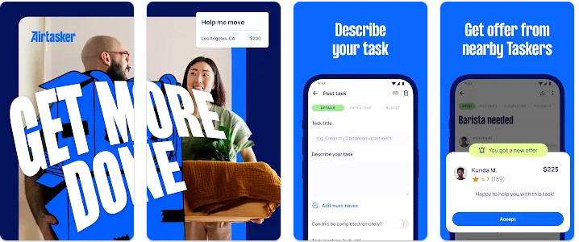*Airtasker*  is a Sydney-based Australian company which provides an online and mobile marketplace enabling users to outsource everyday tasks. Users describe the task and indicate a budget, community members then bid to complete the task

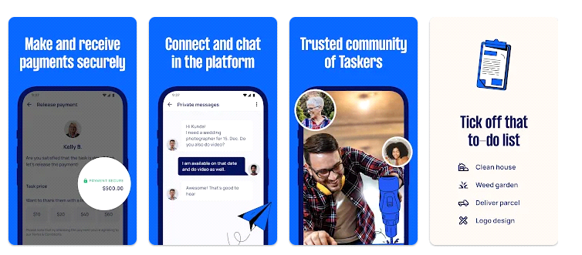

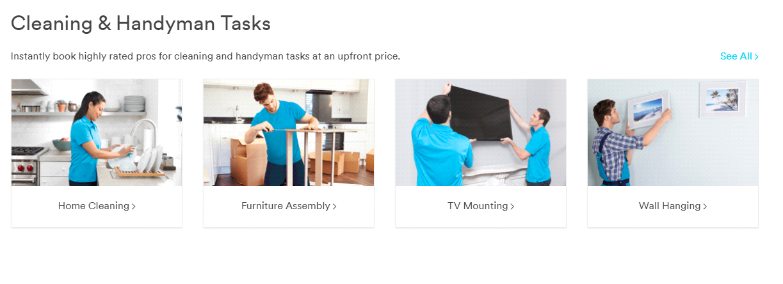*Handy:* Handy is known for connecting users with local professionals for household services like cleaning, plumbing, and electrical work.

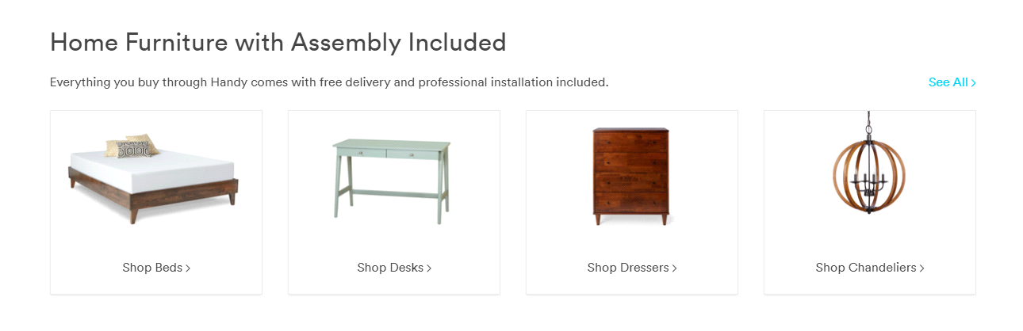

*Wonolo:*Wonolo (which stands for "Work Now Locally") is a platform that connects businesses with on-demand workers for temporary job opportunities. It primarily focuses on providing a flexible workforce for various industries and businesses that require extra hands for short-term assignments

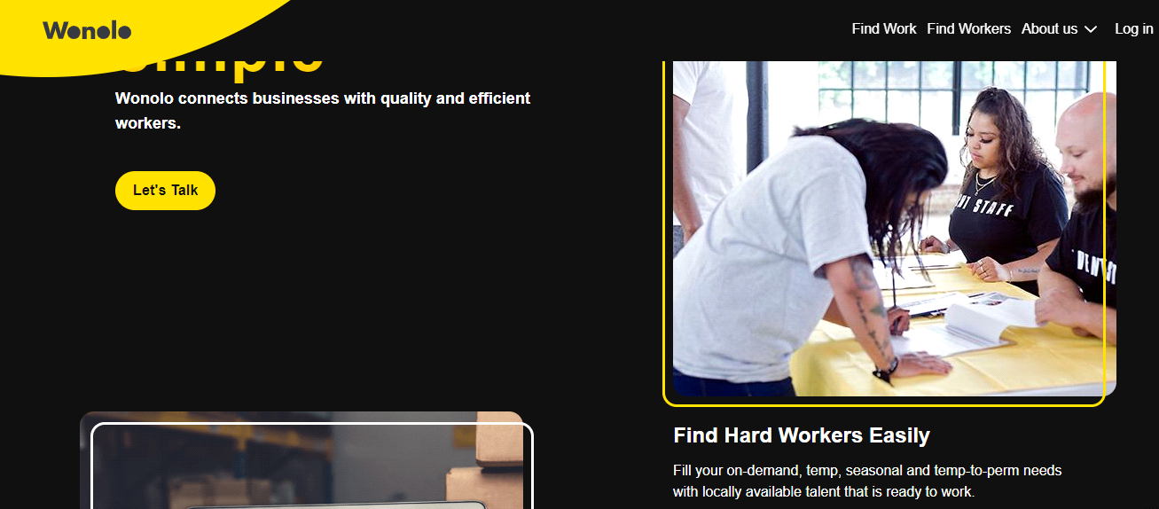

*Thumbtack:* is an American home services website. It is an online directory that allows users to search for, rate, and hire local service providers to work on a variety of personal projects, including home improvement, financial and legal services, computer / IT repair and event planning.

Depending on what skills you have, your service could be anything from pet sitting to house cleaning (or even both). On Thumbtack, you choose the type of jobs you can do in your Services tab. You can add as many services as you want.

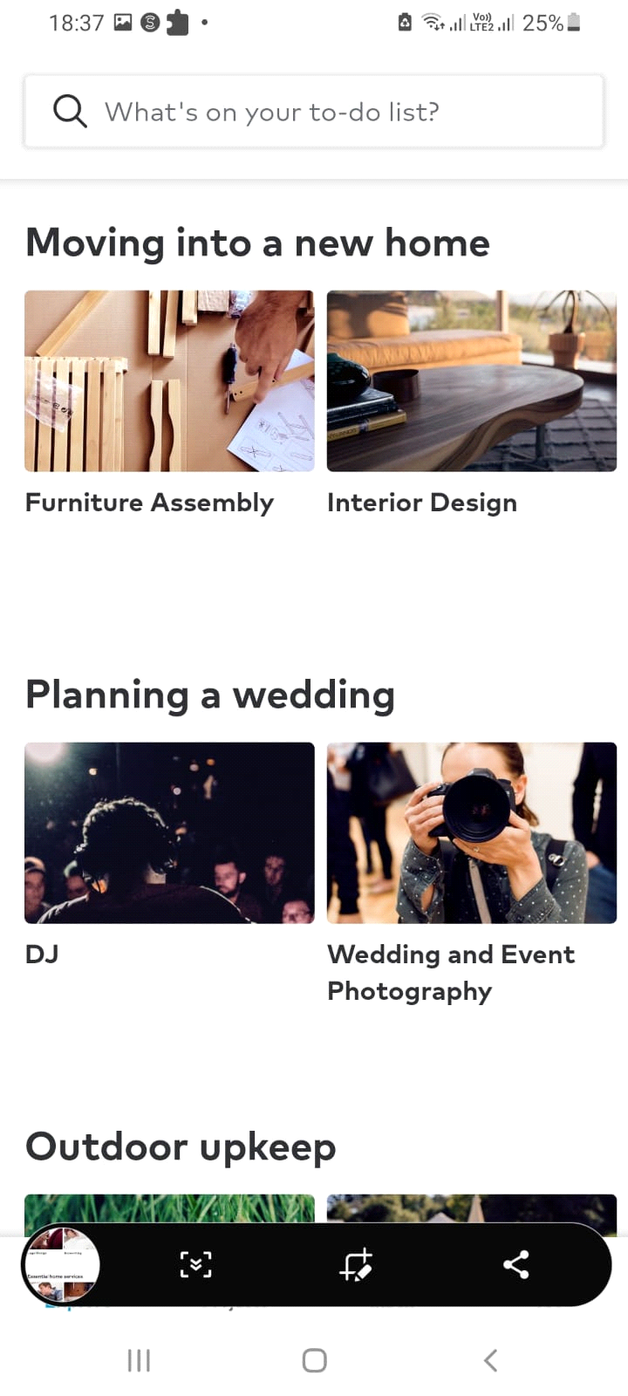**4.0. Critical Analysis**

In the course of our literature review, it has become evident that various systems and platforms have been implemented in the past to address different needs and challenges. However, our proposed system distinguishes itself by its primary focus on saving traveling efforts, a unique characteristic not often observed in existing solutions. The critical analysis of this uniqueness is as follows:

1. **Specific Problem Targeting:**

Many existing systems and platforms cater to a broad range of services and tasks. They may facilitate transactions, provide information, or offer assistance in various domains. Our system, on the other hand, zooms in on a very specific issue: reducing the time, effort, and cost associated with traveling to fulfill small tasks. This specific problem targeting enhances the system's relevance and appeal to a niche audience seeking precisely this solution.

1. **Optimized Resource Allocation:**

The uniqueness of our system lies in its ability to optimize resource allocation in the context of task completion. It minimizes the need for individuals to physically travel by empowering them to delegate their tasks to others within the same location. This not only saves time and effort but also potentially contributes to reduced carbon footprints, making it an environmentally conscious solution.

1. **Tailored User Experience:**

While other systems may offer general assistance or connect users for various purposes, our system customizes the user experience for those who wish to outsource their tasks and for individuals looking to perform these tasks. This tailored approach ensures that users can find the specific help they need, whether it's gathering information, acquiring documents, or completing small errands.

1. **Community-Centric Approach:**

The uniqueness of our system extends to its community-centric nature. By connecting individuals within the same geographical location, it fosters a sense of shared responsibility and community engagement. In doing so, our system not only provides a practical solution but also strengthens social bonds and encourages collaborative problem-solving.

1. **Potential for Broader Applications:**

While our system's primary focus is on saving traveling efforts for small tasks, its underlying principles and infrastructure could potentially be adapted for broader applications. The success of this system could inspire similar platforms addressing other localized challenges and further expanding its uniqueness.

1. **Addressing Emerging Needs:**

In an evolving world where mobility, environmental sustainability, and efficient resource utilization are of increasing concern, our system is uniquely positioned to address emerging needs. It recognizes the changing dynamics of how individuals live and work, acknowledging the importance of minimizing unnecessary travel.

**5.0. Development Environment**

The development environment for the Tech2Connect project encompasses the tools, technologies, and methodologies employed throughout the project lifecycle. This section outlines the key components of the development environment utilized for the successful implementation of the platform.

**5.1. Programming Languages and Frameworks**

The Tech2Connect platform is developed using a combination of programming languages and frameworks chosen for their suitability, efficiency, and scalability. The primary technologies utilized include:

**Programming Languages:**

* HTML, CSS, JavaScript: For frontend development to create interactive and responsive user interfaces.
* FIREBASE: For backend development to implement server-side logic and data management.

**Frameworks and Libraries:**

* **Bootstrap: A front-end framework for developing responsive and mobile-first websites.**

**5.2. Development Tools**

To streamline the development process and enhance collaboration among team members, a suite of development tools is employed. These tools facilitate version control, project management, code editing, and communication. Key development tools include:

* **Version Control:** Git and GitHub are utilized for version control, enabling seamless collaboration, code sharing, and tracking of changes across the development team.
* **Integrated Development Environment (IDE):** Developers use IDEs such as Visual Studio Code, or Sublime Text for code editing, debugging, and syntax highlighting and Firebase for backend development
* **Project Management:** Tools like Notion, Jerra for project planning, task assignment, and progress tracking.
* **Communication:** Platforms like Zoom, Bandicame serve as communication channels for real-time collaboration, discussions, and sharing of updates among team members.
  1. **Infrastructure and Hosting**

The Tech2Connect platform is hosted on a reliable and scalable infrastructure to ensure high availability and performance. Cloud-based hosting services, such as Amazon Web Services (AWS) or Heroku, are leveraged for deployment. These platforms offer features like auto-scaling, load balancing, and database management, enabling seamless deployment and management of the application.

* 1. **Testing and Quality Assurance**

Quality assurance and testing are integral parts of the development process to ensure the reliability, functionality, and security of the platform. Testing methodologies include unit testing, integration testing, and user acceptance testing (UAT). Tools like J unit for automated testing and Postman for API testing are employed to verify the functionality and performance of the platform across different scenarios and environments.

* 1. **Documentation and Knowledge Management**

Comprehensive documentation is maintained throughout the development process to ensure clarity, consistency, and accessibility of information. Documentation includes proposal document, software specification documents, software design documentation, test cases. Additionally, knowledge sharing sessions and code reviews are conducted regularly to foster learning, collaboration, and continuous improvement within the development team.

# Problem Definition:

The modern lifestyle is characterized by its fast pace and a multitude of commitments, which often span across different locations. People frequently find themselves struggling to execute tasks that require physical presence in specific areas. The problems magnify when individuals need to retrieve important documents from governmental institutions or gain access to critical information like doctor appointments, their associated fees, and contact particulars. Moreover, the traditional practice of entrusting courier services to complete such tasks comes with an added layer of complexity, cost, and reliance on unfamiliar third parties. Consequently, there exists a pressing need for a systematic approach to address these challenges and facilitate a seamless process for both task seekers and performers.

## 6.1. Target Audience:

This document is intended for the development team, project managers, stakeholders, and anyone involved in the creation and management of the Tech2Connect platform

## 6.2. Proposed Solution:

Our proposed solution entails the creation of a user-centric website that functions as an intermediary platform connecting individuals in need of assistance with local individuals.

Who can perform tasks on their behalf. The website will be designed with a user-friendly interface that allows task seekers to post their requirements, specify their location, and outline a budget for the task. Meanwhile, those interested in completing these tasks can register on the platform, offering their availability and skillsets. Key features of the platform will encompass secure payment gateways.

1. **Proposed Work and its Methodology**
2. **Platform Development:**

* Design a user-friendly platform that accommodates the needs of both task requesters and task performers.
* Develop a robust backend system that can manage user profiles, task listings, payments, and communications securely.

1. **User Registration and Profiles:**

* Users will create accounts by providing their personal information, location, skills, and interests.
* Task performers' profiles will highlight their capabilities, availability, and expertise.
* Task requesters will list their tasks, specifying task details, location, deadline, and proposed compensation.

1. **Task Listing and Search:**

* Task requesters will post their tasks on the platform, categorizing them for easy navigation.
* Task performers can search for tasks based on location, skillset, and availability.
* An advanced search feature will enhance user experience by enabling filtered searches.

1. **Task Matching and Communication:**

* The platform's algorithm will match task requests with suitable performers based on location and skills.
* Both parties can communicate through the platform's messaging system to clarify task details and expectations.

1. **Task Completion and Compensation:**

* Upon task completion, task requesters will review the performed task and release the confirmation message.

1. **Safety and Trust:**

* Implement verification mechanisms, such as email confirmation and mobile number verification, to enhance user credibility.
* Provide guidelines and best practices to ensure safe interactions and transactions.

1. **Payment System:**

* Task requester will send payment to our account.
* After task completion task requester will release confirmation message.

## Requirements:

**8.1. Functional Requirements: Powering Tech2Connect**

Now that we've explored the external interfaces, let's dive into the core functionalities that make Tech2Connect a game-changer in the world of task assistance. These functions are designed to streamline your experience, whether you're a task requester or a task performer. Let's take a closer look.

**8.1.1 User Registration and Authentication: Your Digital Identity**

Tech2Connect opens its doors to all users, and it all starts with user registration and authentication. The process is straightforward: users can sign up, create their accounts, log in when needed, and authenticate their identity. This ensures that the platform maintains a secure and trustworthy environment for all its users.

**8.1.2 Task Posting: Sharing Your Needs**

This is where your journey begins as a task requester. You can post tasks that need attention, providing all the relevant details. From specifying the task's location to outlining the budget you're willing to allocate, this feature puts you in the driver's seat. Tech2Connect empowers you to share your needs with clarity, making it easier for task performers to understand and offer their services.

**8.1.3 Task Hunting: Finding Opportunities**

Task performers, this one's for you. The task hunting feature lets you search for tasks based on your location and skillset. It's like an opportunity hub where you can discover tasks that align with your capabilities and interests. The ease of finding tasks that match your skills is what sets Tech2Connect apart as a platform built for efficiency and convenience.

**8.1.4. Task Management: Stay in Control**

Task management is at the heart of Tech2Connect. It's the tool that keeps you in control of your tasks. Whether you're a task requester keeping tabs on multiple errands or a task performer juggling various assignments, this feature helps you track and manage tasks effortlessly. It ensures that nothing falls through the cracks, and you're always in the loop.

**8.1.5. Payment and Billing: Secure Transactions**

Financial transactions can often be a source of stress, but not with Tech2Connect. We take security seriously. For task completion, billing, and payments, you can trust that your financial interactions are handled with the utmost care. The platform ensures that all your financial dealings are secure and straightforward.

**8.1.6. Notifications: Stay Informed**

In the fast-paced world of task assistance, staying informed is crucial. Tech2Connect has your back. The notifications feature ensures that you're always in the know about task activities. From bid acceptances to task completions, you'll receive timely updates, so you never miss a beat.

**8.1.7. Search and Filters: Find What You Need**

Efficiency is key, and Tech2Connect knows it. The search and filters feature empowers you to efficiently find tasks. Whether you're a task performer looking for specific types of tasks or a task requester in need of particular assistance, our search and filters feature makes the process quick and hassle-free.

**8.1.8. Messaging System: Connect and Collaborate**

Communication is at the heart of Tech2Connect. The messaging system bridges the gap between task requesters and task performers, enabling seamless communication regarding task details. It's the tool that allows you to connect, clarify, and collaborate, ensuring that everyone is on the same page.

**8.2. Non-Functional Requirements: The Pillars of Tech2Connect's Performance**

While the functionalities and features of Tech2Connect are essential, it's equally crucial to ensure that the platform meets certain non-functional requirements. These requirements form the foundation of Tech2Connect's performance, security, and overall user experience. Let's explore these key pillars:

**8.2.1 Usability: User-Friendly and Intuitive**

Usability is at the forefront of our design philosophy. We're committed to ensuring that the platform is user-friendly and easy to navigate. From registering an account to posting tasks, we aim to make every interaction with Tech2Connect as intuitive and straightforward as possible. We believe that a user-friendly platform is the cornerstone of an exceptional user experience.

**8.2.2 Performance: Lightning-Fast Responsiveness**

Tech2Connect is designed to meet the speed and responsiveness expectations of our users. We understand that in the fast-paced world of task assistance, delays are not an option. Whether you're searching for tasks, communicating with other users, or managing your task list, you can count on Tech2Connect to deliver a lightning-fast experience.

**8.2.3. Reliability: Consistency You Can Trust**

Reliability is non-negotiable. We're committed to delivering consistent and reliable service to our users. When you turn to Tech2Connect for task assistance, you can trust that the platform will be there for you, delivering the services you need, whenever you need them. Our goal is to be a platform you can rely on.

**8.2.4. Availability: Anytime You Need Us**

Being accessible to our users when they need us is a top priority. Tech2Connect is designed to be available and accessible 24/7. Whether it's early in the morning or late at night, you can count on our platform to connect you with the assistance you need. Your convenience is our commitment.

**8.2.5. Scalability: Growing with You**

As the Tech2Connect community grows, so does our platform. We're dedicated to ensuring that Tech2Connect can scale with increasing user demand. The more users who join our community, the stronger and more vibrant it becomes. Our platform's scalability allows us to accommodate all the users who seek assistance and those who are ready to help.

**8.2.6. Security: Protecting Your Data**

Security is paramount in the digital age, and Tech2Connect takes it seriously. We're committed to protecting user data and maintaining a secure environment. Your information is safeguarded to ensure your peace of mind. From your personal details to your financial transactions, you can trust that your data is in safe hands.

**8.2.7. Compatibility: Across Devices and Platforms**

Tech2Connect isn't limited to a single device or platform. We've worked hard to ensure that our platform is compatible across different devices and platforms. Whether you prefer to use it on your desktop, laptop, tablet, or mobile phone, Tech2Connect is designed to provide a consistent and reliable experience.

**8.2.8. Legal and Compliance: Within the Boundaries**

Compliance with relevant laws and regulations is a fundamental commitment. We ensure that Tech2Connect operates within the boundaries of legal and regulatory requirements. Your safety and the integrity of our platform are our top priorities.

**8.2.9. Privacy: Respecting Your Data**

Respecting your privacy and data protection is a core principle of Tech2Connect. We understand the importance of maintaining the confidentiality of your information. You can trust that your privacy is a priority, and your data is handled with care.

**9 Project Management**

**9.1 Work Flow Chart**

**9.2 Project Break down**

|  |  |
| --- | --- |
| **Topics** | **Group Member** |

|  |  |
| --- | --- |
| Phases | Studied by all Group Members |

|  |  |
| --- | --- |
| **Planning and Design(5 weeks)** | |
| Project scope and objectives(1 week) | This will be done by all the group members collectively. |
| Project timeline creation(1 week) | This will be done by all the group members collectively. |
| Gather requirements(1 week) | Kashan Hashim (023-20-0040) |
| Design the user interface and experience(1week) | This will be done by all the group members collectively. |
| Establish the platform’s technical architecture(1 week) | Muhammad Asfandyar (023-20-0041) |

|  |  |
| --- | --- |
| **Development and Testing(9 weeks)** | |
| The web-based platform development (4 weeks) | Muhammad Asfandyar (023-20-0041) |
| Implementing payment processing (2 weeks) | Sharjeel Ahmed (Roll#) |
| QA testing (3 weeks) | Kashan Hashim (023-20-0040) |

|  |  |
| --- | --- |
| **Project Conclusion (2 weeks)** | |
| Project Evaluation(1 week) | This will be done by all the group members collectively. |
| Final Reporting, and Presentation  (1 week) | This will be done by all the group members collectively. (Roll#) |

* 1. 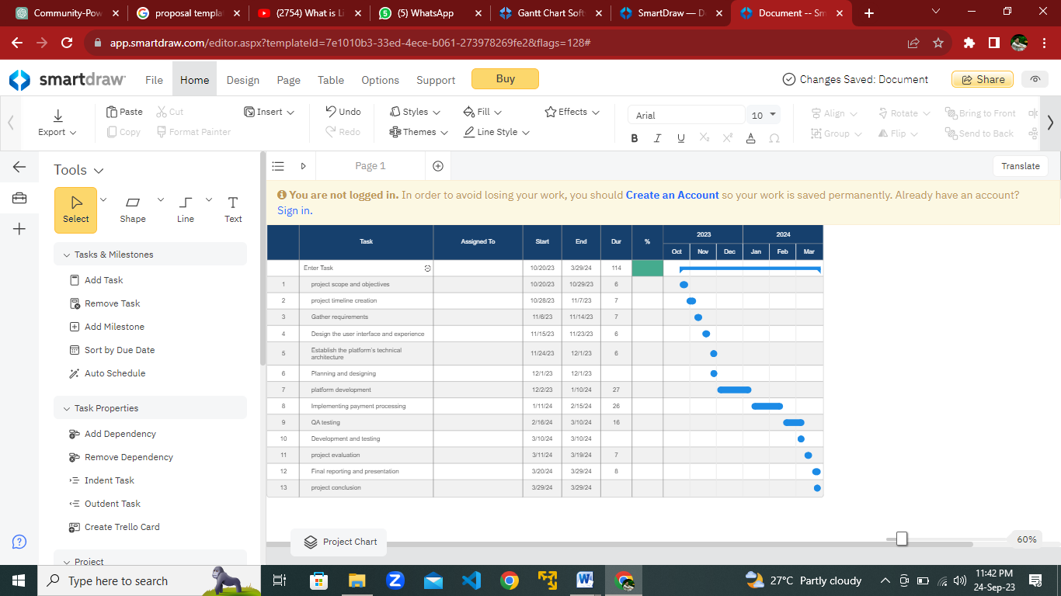**Gantt Chart**

## Detailed Design and Architecture:

The detailed design and architecture for the Tech2Connect platform serves as a comprehensive guide that outlines the technical architecture, design, and specifications for the development and operation of the system. This portion is intended to provide a detailed and structured insight into the platform's design, ensuring that the development team, stakeholders, and any involved parties have a clear understanding of the system's inner workings.

## System Architecture:

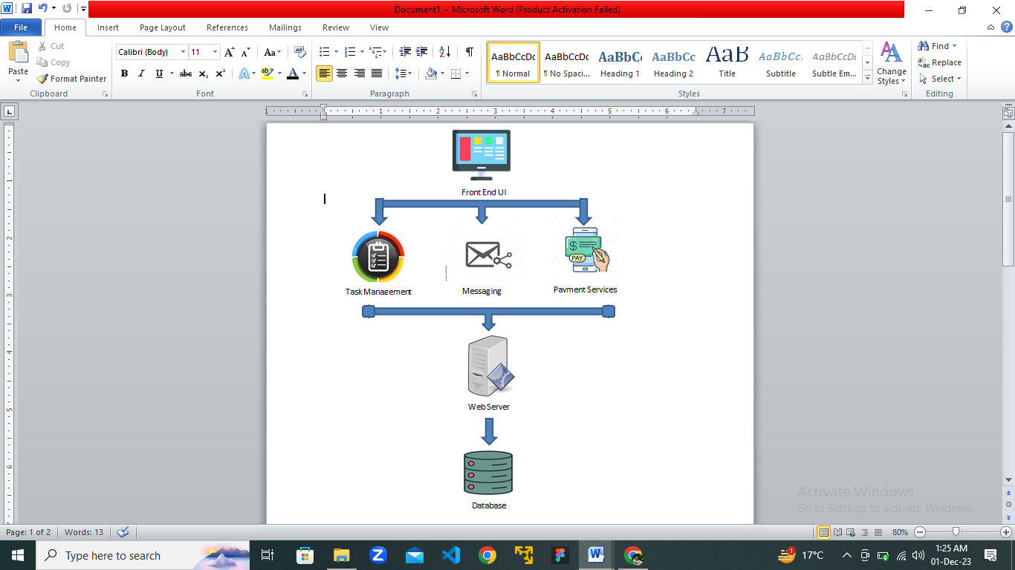

*Figure 1****: System Architecture***

## Architecture design approach:

We have selected Client-Server Architecture in which major computation and resource management are performed and handled at server side. Client access the server and consume the services provided by the server. In this architecture we have central server and many clients’ access and consuming similar type resources. Very low computations are performed at client’s side. In our model, web application is working as client and firebase server works as server to facilitate the clients’ requests.

* 1. ***Entity Relationship Diagram***

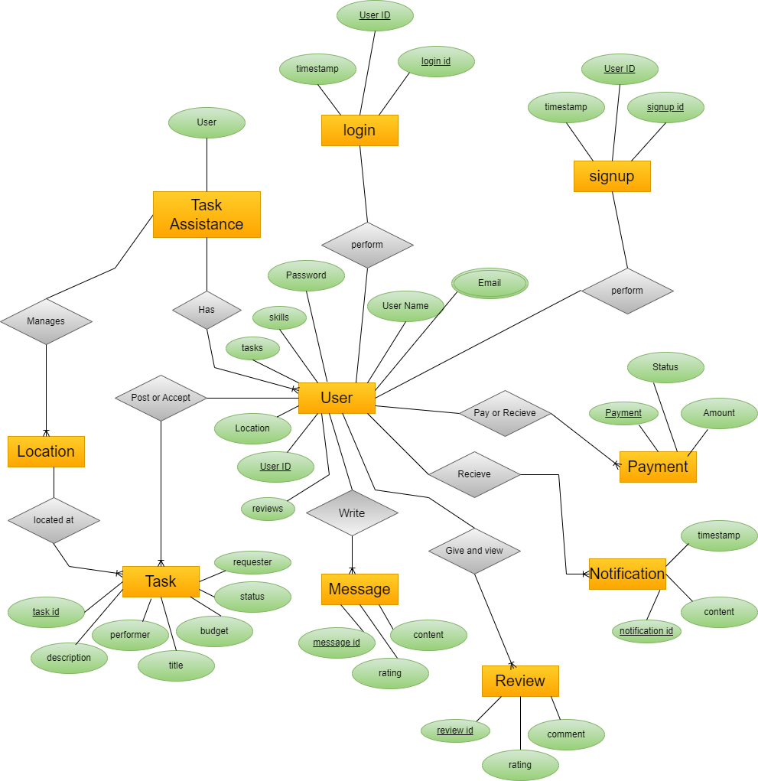

Figure ER Diagram

* 1. ***Sequence Diagram***

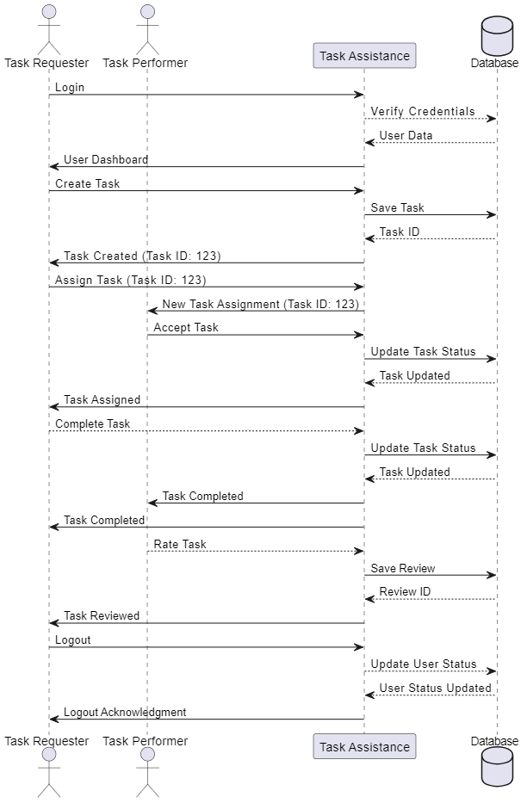

Figure Sequence Diagram

1. **Testing**

Testing is a crucial aspect of the Tech2Connect project, ensuring the reliability, functionality, and security of the platform. This section details the testing methodologies, strategies, and tools employed to validate the platform's performance and usability.

### Testing Methodologies

#### a. Task Functionality Testing:

Task functionality testing focuses on validating the core features and functionalities of the Tech2Connect platform related to task posting, matching, communication, and payment processing. Test cases are designed to verify the accuracy, completeness, and responsiveness of these functionalities.

#### b. User Registration and Profile Testing:

User registration and profile testing ensure that the registration process is seamless, and user profiles are created accurately with all required information. Test scenarios cover user authentication, profile creation, validation of user credentials, and handling of edge cases.

#### c. Task Matching and Communication Testing:

Task matching and communication testing evaluate the platform's ability to match task requesters with suitable task performers based on location, skills, and availability. Testing also assesses the effectiveness of the communication channels, such as messaging systems, in facilitating seamless interactions between users.

#### d. Payment System Testing:

Payment system testing verifies the reliability and security of the platform's payment processing mechanism. Test cases include payment initiation, transaction processing, refund handling, and integration with payment gateways. Security measures, such as encryption and secure authentication, are thoroughly tested to ensure the safety of financial transactions.

### Test Coverage and Metrics

#### a. Code Coverage:

Code coverage metrics are utilized to assess the effectiveness of testing by measuring the percentage of code executed during testing. Tools like coverage.py are employed to analyze code coverage and identify areas that require additional testing or optimization, particularly within critical components related to task management and payment processing.

#### b. Performance Testing:

Performance testing evaluates the responsiveness and scalability of the Tech2Connect platform under different load conditions. Tools like Apache JMeter or locust.io are utilized to simulate concurrent user activity, analyze response times, and identify performance bottlenecks. Performance benchmarks are established to ensure that the platform meets performance requirements and can handle expected user traffic without degradation.

# Conclusion:

In conclusion, the proposed platform offers a comprehensive solution to the challenges faced by individuals needing assistance with tasks that involve travel and presence in various locations. By creating an ecosystem where users can easily connect with local task performers, we aim to streamline everyday tasks, reduce costs, and create earning opportunities for individuals looking to supplement their income. This initiative not only addresses a pertinent issue in modern society but also reflects our commitment to fostering community collaboration and enhancing the overall quality of life. Through the amalgamation of technology, convenience, and empowerment, we envision a future where no task is too small to be managed efficiently and effectively

# Future Work:

* We will launch Tech2Connect in market.
* We will add bidding system between tasker and task poster.
* We will add live location about task.

1. **References**

**14.1. Air tasker**

Title of the document or source: Air tasker - Find Someone Perfect for Your Task

Report number: N/A

Date: N/A

Publishing organization: Air tasker

Source location: Retrieved from [Air tasker](https://www.airtasker.com/au/)

**14.2. Wonolo**

Title of the document or source: Wonolo - Work Now Locally

Report number: N/A

Date: N/A

Publishing organization: Wonolo

Source location: Retrieved from [Wonolo](https://www.wonolo.com/)

**14.3. Thumbtack**

Title of the document or source: Thumbtack - Local Service Providers

Report number: N/A

Date: N/A

Publishing organization: Thumbtack

Source location: Retrieved from [Thumbtack](https://www.thumbtack.com/)

**14.4. Handy**

Title of the document or source: Handy - Household Services

Report number: N/A

Date: N/A

Publishing organization: Handy

Source location: Retrieved from [Handy](https://www.handy.com/)